COMMUNICATION NETWORKS - ASSIGNMENT 5 (May, 4th, 2023)

“Virtualization of Network Resources”

Homework assignments are an integral part of this course. You are expected to complete your work on time and in an honest manner. You may collaborate with other students. However, you should write up and hand in your assignment separately, indicating in which parts and with whom you have collaborated. Failing to do that will be considered as cheating or plagiarism, and the student will be subject to disciplinary actions. The following list would help students to be aware of the related rules and obligations:
Do not submit work that is not entirely yours, i.e., use of another student’s essay or use of a downloaded essay from the Internet.
Acknowledge all assistance received, including help from friends or others in terms of proofreading, suggestions or information.
Do not lend your work to other students unless you feel certain they will not use it dishonestly.
When in doubt about any practice, ask the teachers. Do not rely on friends, relatives or fellow students for information about what is acceptable academic practice.
When material you read impresses you, be particularly careful to use your own words. Cite sources whenever you use the words of another.
Make sure that you are able to explain any part of your work if asked by the teacher.

The weight of this assignment is 20% of the final mark of the course.

Work to do

- Software implementation: Python.
  - Define an structure for the adjacency matrix, able to support the topologies of the figure.
To be able to calculate the adjacency matrix we need to set some parameters:
- The number of iterations in case it does not find an optimal solution:
- The direct graph attribute if “True” the network would be directed in the direction in which the links are defined. If “False” all the links in the network are bidirectional.
- The demands: it indicates the demands willing to be allocated.
- The route: it indicate the origin and destination of each demand.
- Node: it indicate the list of all the nodes available.
- Links: it indicates the list of the links between nodes and its capacity
N_ITERATIONS = 10 # Setting the value of the variable 'N_ITERATIONS' to 10
DIRECTED_GRAPH = False # Setting the value of the variable 'DIRECTED_GRAPH' to False
demands = np.array([[8, 8, 5], [4, 6, 2]]) # Creating a NumPy array 'demands' with shape (2, 3)
routes = np.array([[1, 5], [5, 1]]) # Creating a NumPy array 'routes' with shape (2, 2)
nodes = [1, 2, 3, 4, 5] # Creating a list 'nodes' with five elements
links = [(1, 2, 12), (2, 3, 10), (2, 4, 7), (3, 5, 8), (4, 5, 6)] # Creating a list 'links' with five tuples
To calculate the adjacency matrix, I have used the Networkx library which intern needs the library scipy to properly work. As an output the code developed prints the initial adjacency matrix and at the end the updated one.
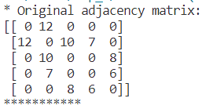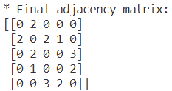
  - Consider the following metric: Maximize the Acceptance Ratio.
  - For each demand, calculate and print a list of all the possibilities to be allocated.
The code developed indicates for each demand the possible paths.
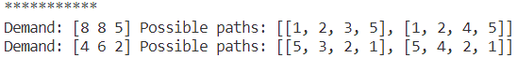
  - Indicate the allocation decided to accommodate the demands.
Following it can be found a screenshot of the output generated by the program where it can be observed the original adjacency matrix, all the possible paths for each demand, the demands that could be allocated, the demands that could not be allocated and the resulting adjacency matrix.
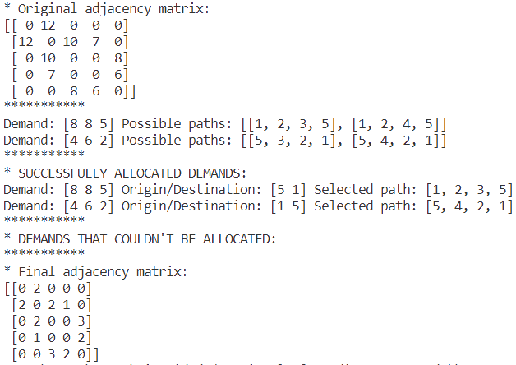
In the following screenshot a test with non-allocatable demands is provided:
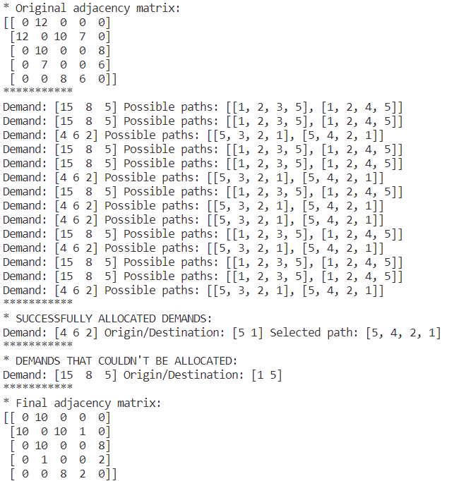
In the previous figure we can observe that as the first demand it cannot be allocated it does the iteration of the first demand ten times as established in point a. We can also see that the first demand appears on the demands that couldn’t be allocated space.

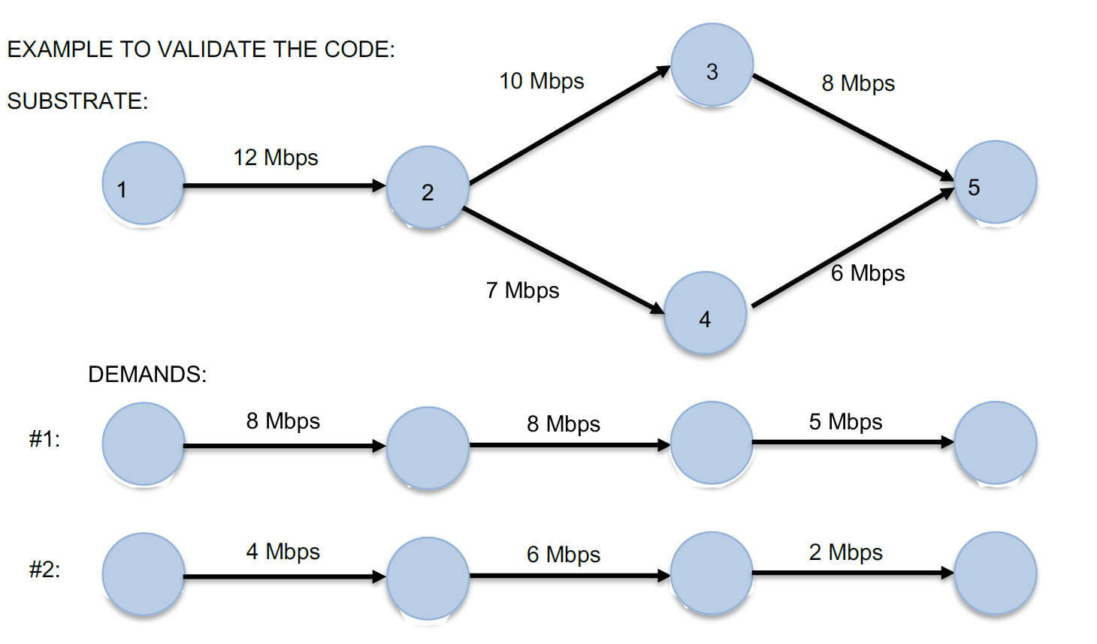

- Discussion. Answer the following questions.
  - What are the potential risks in the step c.
In step c) of calculating and printing a list of all possibilities for each demand, there are a few potential risks to consider:
- Combinatorial explosion: Depending on the size of the substrate network and the demands, the number of possible allocations can grow exponentially. This can lead to a significant increase in computational complexity and memory usage. As the number of demands and the complexity of the network increase, the time and resources required to generate and store all possible allocations can become impractical.
- Memory limitations: Storing all possible allocations for each demand can consume a large amount of memory, especially for larger networks or a large number of demands. If the memory available is limited, it may not be feasible to store all the allocations simultaneously. In such cases, you might need to consider alternative strategies like generating and evaluating allocations on-the-fly rather than storing them all in memory.
- Performance issues: Generating and evaluating a large number of allocations can be computationally expensive and time-consuming. If the demands or network size are substantial, it may take a considerable amount of time to compute all the possibilities. This could impact the responsiveness and efficiency of the overall system.
- Infeasible allocations: Not all combinations of demands and resources may be feasible or valid. Some demands might not have suitable resources available to accommodate them, leading to infeasible allocations. It is crucial to consider the constraints and limitations of the substrate network and ensure that the generated allocations are valid and can be implemented in practice.
  - Indicate other possible decision criteria.
In addition to maximizing the acceptance ratio, there are several other decision criteria we can consider when selecting the best allocation from the possibilities generated:
- Minimize resource utilization: instead of maximizing the acceptance ratio, we might prioritize minimizing the overall resource utilization aiming to allocate demands in a way that minimizes the consumption of resources in the substrate network, potentially leading to more efficient and cost-effective allocations.
- Load balancing: we can prioritize load balancing across the substrate network by aiming for an even distribution of demands among the available resources helping to prevent resource bottlenecks and ensuring that the network operates optimally without any overloaded nodes or links.
- Latency optimization: if reducing latency or improving response time is crucial, we can consider allocating demands based on minimizing the communication delays between the allocated resources by prioritizing low-latency paths and enhancing the overall performance of the network.
- Quality of Service (QoS) requirements: different demands might have varied QoS requirements, such as bandwidth, reliability, or security. We can incorporate these requirements as decision criteria and allocate demands based on their specific QoS needs ensuring that each demand receives the necessary resources and guarantees the desired level of service.
- Cost optimization: if cost is a significant factor, we can include it as a decision criterion considering factors such as resource pricing, power consumption, or network maintenance costs when selecting the best allocation trying to find an allocation that meets the demands while minimizing the associated costs.

- Code
Following the phyton code can be find and it is also provided as a python file:
import numpy as np # Importing the NumPy library and assigning it the alias 'np'
import networkx as nx # Importing the NetworkX library and assigning it the alias 'nx'
import copy # Importing the copy module
import scipy as sp # Importing the SciPy library and assigning it the alias 'sp'

N_ITERATIONS = 10 # Setting the value of the variable 'N_ITERATIONS' to 10
DIRECTED_GRAPH = False # Setting the value of the variable 'DIRECTED_GRAPH' to False

demands = np.array([[15, 8, 5], [4, 6, 2]]) # Creating a NumPy array 'demands' with shape (2, 3)
routes = np.array([[1, 5], [5, 1]]) # Creating a NumPy array 'routes' with shape (2, 2)

nodes = [1, 2, 3, 4, 5] # Creating a list 'nodes' with five elements
links = [(1, 2, 12), (2, 3, 10), (2, 4, 7), (3, 5, 8), (4, 5, 6)] # Creating a list 'links' with five tuples

def path_weights(W, path): # Defining a function 'path_weights' that takes two arguments: 'W' and 'path'
weights = [] # Creating an empty list 'weights'
for i in range(len(path) - 1): # Looping over the range from 0 to len(path) - 2
weights.append(W[path[i]][path[i + 1]]["weight"]) # Appending the weight value from the graph to the 'weights' list
return weights # Returning the 'weights' list

def find_better_fitted_path(W, demand, paths): # Defining a function 'find_better_fitted_path' that takes three arguments: 'W', 'demand', and 'paths'
fitness = [] # Creating an empty list 'fitness'
for path in paths: # Looping over the 'paths' iterable
pw = path_weights(W, path) # Calling the 'path_weights' function to calculate the weights of the 'path'
difference = np.array(pw) - np.array(demand) # Calculating the element-wise difference between 'pw' and 'demand' arrays
if not np.any(difference < 0): # Checking if there are no negative values in the 'difference' array
fitness.append(np.sum(difference)) # Appending the sum of 'difference' array to 'fitness' list
else:
fitness.append(999999) # Appending a large value (999999) to 'fitness' list
if np.any(np.array(fitness) != 999999): # Checking if there exists a value other than 999999 in the 'fitness' array
return np.argmin(fitness) # Returning the index of the minimum value in the 'fitness' array
else:
return -1 # Returning -1 if all fitness values are 999999

def allocate_demand(graph, origin, destination, demand): # Defining a function 'allocate_demand' that takes four arguments: 'graph', 'origin', 'destination', and 'demand'
paths = nx.all_simple_paths(graph, origin, destination) # Generating all simple paths between 'origin' and 'destination' in the 'graph'
paths = list(paths) # Converting the 'paths' generator to a list
print("Demand:", demand, "Possible paths:", paths) # Prints all the possible path for each demand
fittest_path = find_better_fitted_path(graph, demand, paths) # Finding the best fitted path for the 'demand' using 'find_better_fitted_path' function
if fittest_path == -1: # Checking if no fittest path was found
return -1 # Returning -1
path = paths[fittest_path] # Selecting the fittest path from the 'paths' list
for i in range(len(path) - 1): # Looping over the range from 0 to len(path) - 2
new_capacity = graph[path[i]][path[i + 1]]['weight'] - demand[i] # Calculating the new capacity of the link
graph[path[i]][path[i + 1]]['weight'] = new_capacity # Updating the capacity of the link in the 'graph'
return [graph, path] # Returning a list containing the 'graph' and 'path'

optimal_solution = False # Setting the value of the variable 'optimal_solution' to False

if DIRECTED_GRAPH: # Checking the value of 'DIRECTED_GRAPH'
W = nx.DiGraph() # Creating a directed graph object and assigning it to 'W'
else:
W = nx.Graph() # Creating an undirected graph object and assigning it to 'W'
W.add_nodes_from(nodes) # Adding nodes to the graph 'W'
W.add_weighted_edges_from(links, weight='weight') # Adding weighted edges to the graph 'W'

print("* Original adjacency matrix:") # Printing a message indicating the original adjacency matrix
adj_matrix = nx.adjacency_matrix(W).toarray() # Calculating the adjacency matrix of the graph 'W' and converting it to a NumPy array
print(adj_matrix) # Printing the adjacency matrix
print("***********") # Printing a separator line

acceptance_ratio_record = [] # Creating an empty list 'acceptance_ratio_record'
demands_record = [] # Creating an empty list 'demands_record'
routes_record = [] # Creating an empty list 'routes_record'

acceptance_ratio = 0 # Initializing the variable 'acceptance_ratio' with 0

for i in range(N_ITERATIONS): # Looping from 0 to N_ITERATIONS - 1
allocated = 0 # Initializing the variable 'allocated' with 0
W_buff = copy.deepcopy(W) # Creating a deep copy of the graph 'W' and assigning it to 'W_buff'
demand_allocation = [] # Creating an empty list 'demand_allocation'
for d in range(len(demands)): # Looping over the range from 0 to the length of 'demands' array - 1
origin = routes[d][0] # Assigning the value of the first element in 'routes[d]' to 'origin'
destination = routes[d][1] # Assigning the value of the second element in 'routes[d]' to 'destination'
out = allocate_demand(W_buff, origin, destination, demands[d]) # Allocating the demand using 'allocate_demand' function
if out == -1: # Checking if demand allocation was unsuccessful
demand_allocation.append([demands[d], -1]) # Appending the demand and -1 to 'demand_allocation' list
else:
demand_allocation.append([demands[d], out[1]]) # Appending the demand and allocated path to 'demand_allocation' list
W_buff = out[0] # Updating 'W_buff' with the allocated graph
allocated += 1 # Incrementing the 'allocated' variable
acceptance_ratio = allocated / len(demands) # Calculating the acceptance ratio
acceptance_ratio_record.append(acceptance_ratio) # Appending the acceptance ratio to 'acceptance_ratio_record' list
demands_record.append(copy.deepcopy(demands)) # Appending a deep copy of 'demands' array to 'demands_record' list
routes_record.append(copy.deepcopy(routes)) # Appending a deep copy of 'routes' array to 'routes_record' list
shuffler = np.random.permutation(len(demands)) # Creating a random permutation of indices for 'demands' array
demands = demands[shuffler] # Reordering 'demands' array using the shuffled indices
routes = routes[shuffler] # Reordering 'routes' array using the shuffled indices
if acceptance_ratio == 1: # Checking if the acceptance ratio is 1 (optimal solution found)
optimal_solution = True # Setting 'optimal_solution' to True
break # Exiting the loop

if not optimal_solution: # Checking if optimal solution was not found
best = np.argmax(acceptance_ratio_record) # Finding the index of the highest acceptance ratio
demands = demands_record[best] # Updating 'demands' with the demands from the best iteration
routes = routes_record[best] # Updating 'routes' with the routes from the best iteration
W_buff = copy.deepcopy(W) # Creating a deep copy of the graph 'W' and assigning it to 'W_buff'
demand_allocation = [] # Creating an empty list 'demand_allocation'
for d in range(len(demands)): # Looping over the range from 0 to the length of 'demands' array - 1
origin = routes[d][0] # Assigning the value of the first element in 'routes[d]' to 'origin'
destination = routes[d][1] # Assigning the value of the second element in 'routes[d]' to 'destination'
out = allocate_demand(W_buff, origin, destination, demands[d]) # Allocating the demand using 'allocate_demand' function
if out == -1: # Checking if demand allocation was unsuccessful
demand_allocation.append([demands[d], -1]) # Appending the demand and -1 to 'demand_allocation' list
else:
demand_allocation.append([demands[d], out[1]]) # Appending the demand and allocated path to 'demand_allocation' list
W_buff = out[0] # Updating 'W_buff' with the allocated graph

print("***********") # Printing a separator line
print("* SUCCESSFULLY ALLOCATED DEMANDS:") # Printing a message indicating the successful demand allocations
for i in range(len(demand_allocation)): # Looping over the range from 0 to the length of 'demand_allocation' list - 1
if demand_allocation[i][1] != -1: # Checking if the allocated path is not -1 (demand was successfully allocated)
print("Demand:", demand_allocation[i][0], "Origin/Destination:", routes[i], "Selected path:", demand_allocation[i][1]) # Printing the demand, origin/destination, and selected path
print("***********") # Printing a separator line

print("* DEMANDS THAT COULDN'T BE ALLOCATED:") # Printing a message indicating the demands that couldn't be allocated
for i in range(len(demand_allocation)): # Looping over the range from 0 to the length of 'demand_allocation' list - 1
if demand_allocation[i][1] == -1: # Checking if the allocated path is -1 (demand couldn't be allocated)
print("Demand:", demand_allocation[i][0], "Origin/Destination:", routes[i]) # Printing the demand and origin/destination
print("***********") # Printing a separator line

print("* Final adjacency matrix:") # Printing a message indicating the final adjacency matrix
adj_matrix = nx.adjacency_matrix(W_buff).toarray() # Calculating the adjacency matrix of the allocated graph and converting it to a NumPy array
print(adj_matrix) # Printing the adjacency matrix

